Mirae Asset Investment Managers (India) Private Limited
Unit No 606, Windsor Building, 6th Floor
Kalina, Santacruz (East), Mumbai -400098

List of Simple and Performing Schemes for New Cadre of Distributors
The below mentioned schemes of Mirae Asset Mutual Fund are the simple and performing schemes, which are eligible for distribution by new cadre of distributors, in accordance with SEBI circular dated September 13, 2012:
- Mirae Asset Emerging Bluechip Fund
- Mirae Asset Tax Saver Fund
Scheme Classification and Objective:
Mirae Asset Emerging Bluechip Fund
(Large & Mid Cap Fund - An open ended equity scheme investing in both large cap and mid cap Stocks)
Investment Objective
The investment objective of the scheme is to generate income and capital appreciation from a portfolio primarily investing in Indian equities and equity related securities of large cap and mid cap companies at the time of investment. From time to time, the fund manager may also seek participation in other Indian equity and equity related securities to achieve optimal Portfolio construction. The Scheme does not guarantee or assure any returns.
Asset Allocation
- Indian Equities and Equity Related Securities* of Large cap companies (top 100 stocks by market capitalization at the time of investment): 35% to 65%
- Indian Equities and Equity Related Securities* of Mid cap companies (which are not part of the Top 100 stocks but fall within Top 250 stocks by market capitalization at the time of investment): 35% to 65%
- Money market instruments / debt securities Instruments: 0% to 30% (Including up to 25% of corpus in securitized debt).
Transparency: The NAV will be calculated at the close of every working day and shall be published on the AMFI /AMC website.

Mirae Asset Tax Saver Fund
(An open ended equity linked saving scheme with a statutory lock in of 3 years and tax benefit)
Investment Objective
The investment objective of the scheme is to generate long term capital appreciation from a diversified portfolio of predominantly equity and equity related instruments. The Scheme does not guarantee or assure any returns.
Asset Allocation
- Equity and Equity Related Instruments: 80% to 100%
- Debt Instruments, Money Market Instruments, G-Secs, Cash, CBLO, Reverse Repo, etc.: 0% to 20%
Transparency: The NAV will be calculated at the close of every working day and shall be published on the AMFI /AMC website.
Product Labelling:

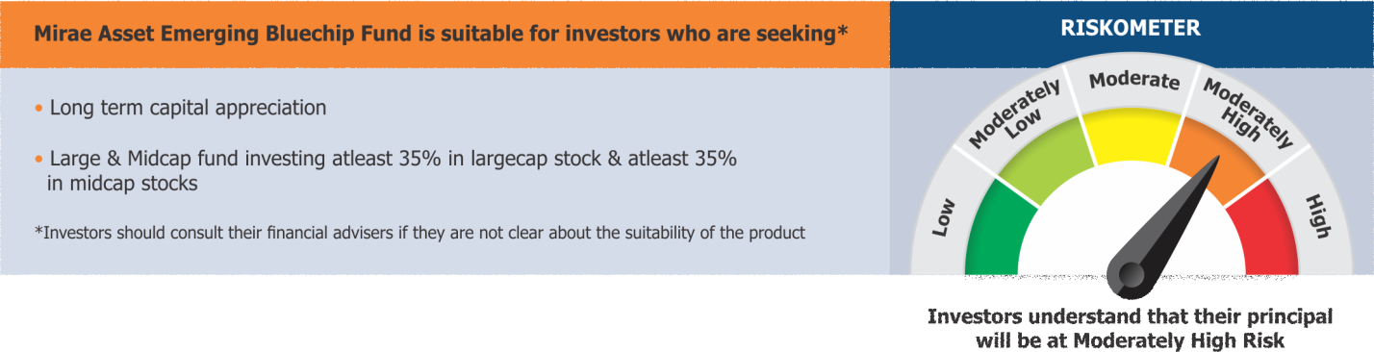
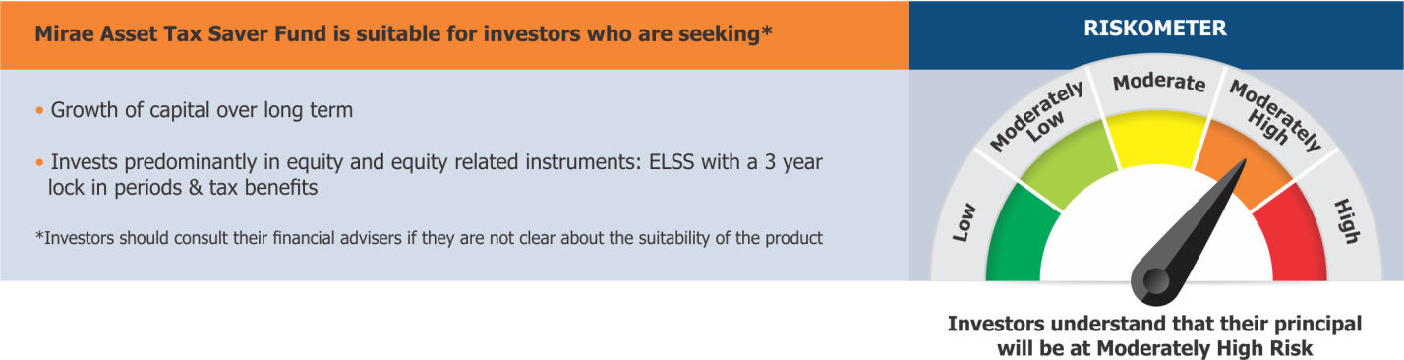
MUTUAL FUND INVESTMENTS ARE SUBJECT TO MARKET RISKS, READ ALL SCHEME RELATED DOCUMENTS CAREFULLY.

